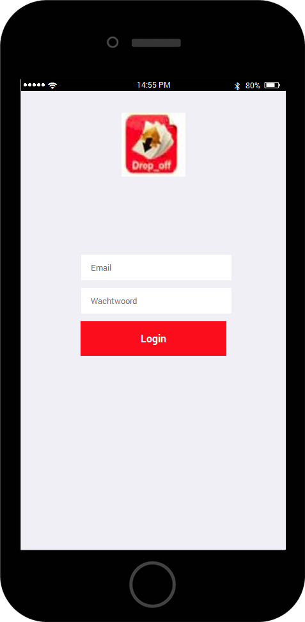
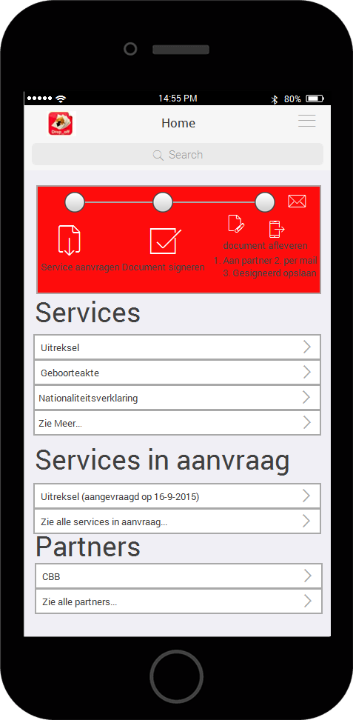
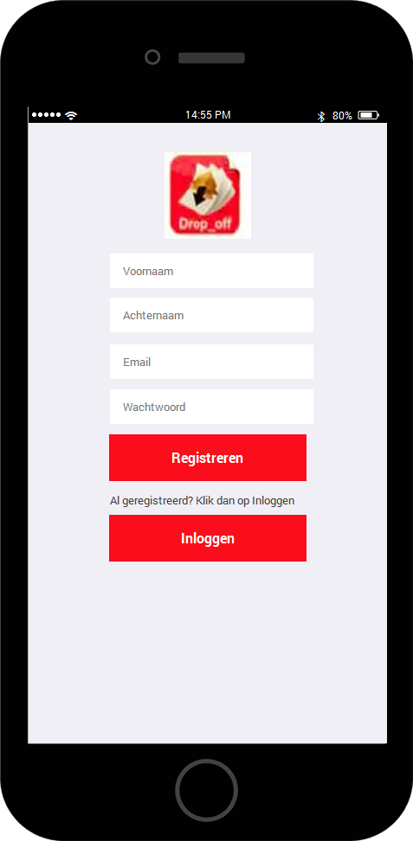

After downloading the app you get a register screen. You can choose to register or to login if you already are registered.
After registering or login you get the home screen which shows: 1. The ham burgerbar at the top 2. the flow for the user 3. The available services 4. The services that are in progress 5. The partners with which we work.

sad
If you click on the hamburger bar in de homescreen. A dropdown will show for Profile and billing history
Third mockup is the profile mockup. The details can be authenticated with sms. And the user can put a signature for signing documents

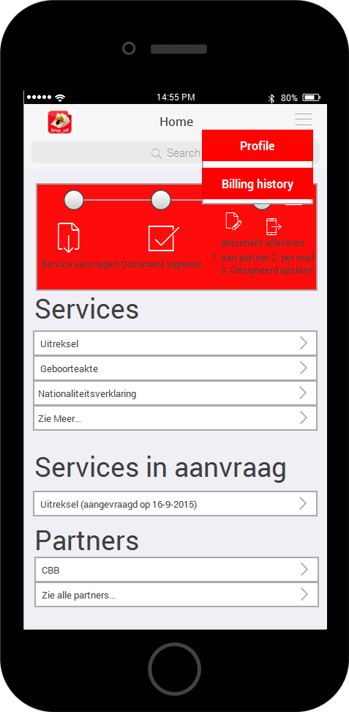
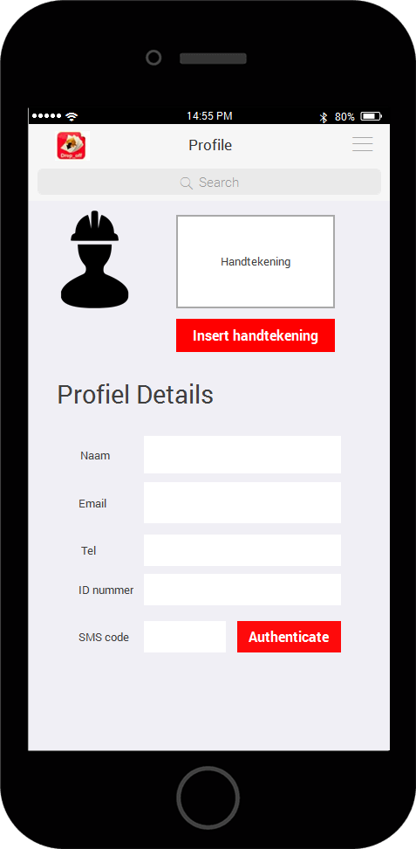
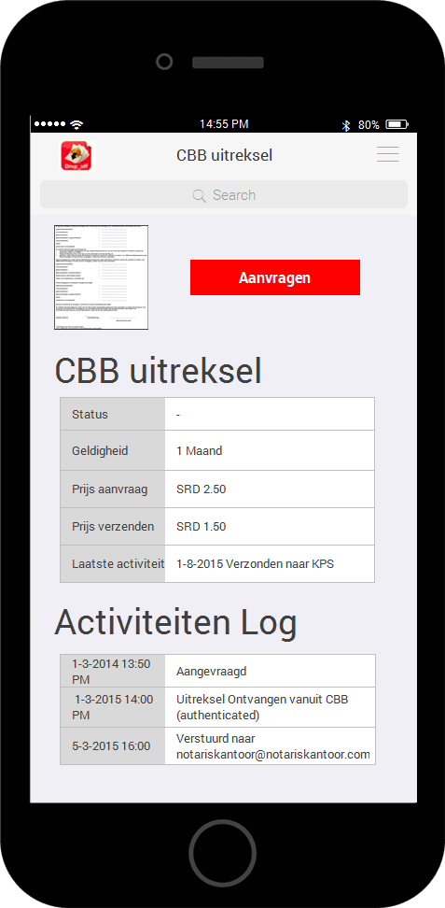
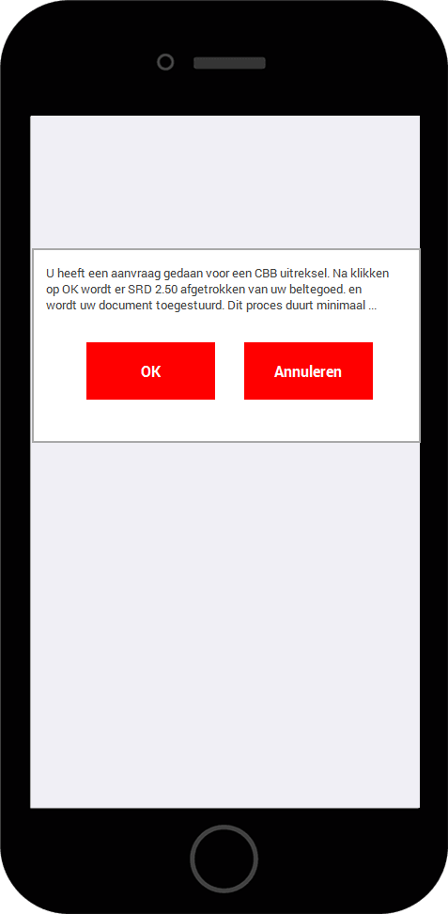
If you click on one of the services in the home screen. The detail screen of that service will show. The detailscreen shows the price of the service ( in this case the price of requesting the document and sending the document). And also the activities regarding the document (service)
If you click on aanvragen then a popup shows for payment

